IT RCSA Audit Documentation
Segregated Environments – BSI.IT.23.C4
Design Assessment, Walkthrough and Sample of One (DH 3264 Derivatives NDF – T24 environments) – tested from scratch with the 10/30/2026 evidence
DESIGN RATING | SAMPLE NDF | CPA RATING | OBSERVATIONS
SATISFACTORY | PASS | SATISFACTORY | OBS-12 – OBS-16

Control | BSI.IT.23.C4 – Segregated Environments (Heracles ID 50541463) – Key, Hybrid (Heracles: Semi-Automated), Annual
Statement | Software Development and QA teams develop and test code in non-production environments. Exceptions must be approved by Information Security.
Risk | BSI.IT.23.R3 Inadequately Configured Sys – inappropriate data disclosures caused by the production version into the IT environment (Inherent Moderate)
Review period | 09/01/2025 – 08/31/2026 – 2 samples: ALCO – Security Lending and Derivatives NDF (evidence folder)
Test date / tester | 10/30/2026 – IT RCSA
Test script | No C4 script in the IT RCSA 2026 Test Plan "New test scripts" tab and no 2025 script in the Tracker – proposed 9-step script (00 Reference)
Walkthrough | No 2026 walkthrough held; to be scheduled with Jose Luis Martinez Avial / T24 team to answer OBS-12 to OBS-16.
Sample of one | Sample 2 – DH 3264 Derivatives NDF: T24 production (miasx1 / ENVmiaprd) vs non-production (miasx4 / ENVmiaaft28); Sample 1 Security Lending tested in the workpaper
Evidence folder | C4 Segregated Env\CDA and C4 Segregated Env\CPA (BSI.IT.23.C4.01 – C4.07)

1. Design Effectiveness Summary
The control design appears effective for T24. Segregation is system-enforced: production and non-production run on different servers, IP addresses and T24 environments, and code reaches production only through ServiceNow release / change tickets after testing in non-production. Exceptions (development or testing in production) require Information Security approval. Hybrid nature is appropriate: the infrastructure enforces separation, while exception approval is manual.
HERACLES question | Answer | Rationale (2026)
1 Frequency / trigger | Yes | Segregation continuously enforced; Heracles "Annual" confirmation; activity per release (OBS-09).
2 Audit trail / evidence | Yes | DNS / server / environment records and T24 data per environment (C4.03 / C4.08); release tickets (C4.04 – C4.07).
3 Policy alignment | Yes | 2026 SDLC process map (C4.01) and US SDLC / secure development requirements.
4 Thresholds | N/A | Applies to all development and testing.
5 Escalation | Partial | InfoSec approval of exceptions stated, but no exception process / register evidenced; who monitors not defined.
6 Information reliability | Moderately Reliable | System data captured by manual, undated screenshots.
7 Evidence obtainable | Yes | Screenshots produced by the T24 team on request.

Design observation OBS-09: the statement lacks who performs / monitors the control, the evidence retained and the exception escalation path; the Test Plan Control Articulation Tracker rates it a "process statement … currently untestable". Adopt the 2026 proposed statement (exceptions approved by the CISO or delegate; evidence: production and non-production domains, code repositories and hosts) and align the frequency. CDA rating Satisfactory to be confirmed with the reviewer given the Partial escalation answer.

2. WT Summary
Model walkthrough language (RCSA CDA Job Aid §4.1): On 10/30/2026, IT RCSA performed a Test of One for BSI.IT.23.C4 through inspection of the T24 environments of the two samples provided in the evidence folder – ALCO Security Lending and Derivatives NDF. The control is enforced by the infrastructure and performed by the T24 Development / QA teams, who build and test in MIAAFT28 before promotion through ServiceNow. The tester reviewed nslookup results (miasx1 → 180.201.151.152; miasx4 → 180.201.1.156), the T24 Server Login / Environments screens (ENVmiaprd vs ENVmiaaft28) and the ND.DEAL lists in each environment (test NDF deals dated 11/2025 in MIAAFT28; live deals 03 – 07/2026 in production), plus the release tickets recording testing before deployment. The evidence is retained by the T24 team / ServiceNow. Exceptions require Information Security approval – no exception register was provided. Variations: Appian (Security Lending Workflow) environments were not evidenced. Based on the Test of One, segregation exists for T24; both samples pass; the remaining items are observations OBS-12 to OBS-16.
Competency (Job Aid §4.4): to be assessed in the 2026 walkthrough with the control owner and the T24 team (environment administration and exception approvals).

3. Sample of One – Sample 2 DH 3264 Derivatives NDF (T24 environments)
Attribute | Value / conclusion | Evidence reference | Result
Separate production environment | Server miasx1, IP 180.201.151.152, environment ENVmiaprd – "T24 Desktop – BANCO SANTANDER INTL." | C4.03 / C4.08 | Pass
Separate non-production environment | Server miasx4, IP 180.201.1.156, environment ENVmiaaft28 – "MIAAFT28 ON MIASX4 – SANTANDER OCT 2025 EOM" | C4.03 / C4.08 | Pass
Development / testing in non-production | NDF test deals (ND.DEAL, 11/2025) in MIAAFT28 before R01 production 01/28/2026; testing recorded in all 4 release tickets | C4.03 – C4.08 | Pass
Developer access to production restricted | Same login ID "MIASANG" used on both servers – owner / privileges not evidenced | C4.03 / C4.08 | Pass – OBS-12
Production data in non-production | Non-production labelled "OCT 2025 EOM" with client counterparties – masking / InfoSec approval not evidenced | C4.03 / C4.08 | Pass – OBS-13
Exceptions approved by InfoSec | No development / testing in production found for the sample, so no approval needed; no register kept | C4.04 – C4.07 | Pass – OBS-14
Appian environments (SL R01) | Not shown; DEV / UAT tests recorded before go-live | C4.06 | Pass – OBS-16

Conclusion: T24 development / test and production environments are segregated and the 2026 releases were tested in non-production before deployment. The sample passes. Management should still answer the observations: the exception register and Appian environment evidence (OBS-14, OBS-16), the shared MIASANG login (OBS-12) and the production-data copy in MIAAFT28 (OBS-13).

NewTest Script coverage (workpaper tab "New Test Script")
Step | Test script step | Answer | Result
1 | Obtain Evidence | Environment screenshots, release tickets | Completed
2 | Completeness & Accuracy | Scope from SDLC Project List | Pass – OBS-11
3 | Population & Scope | 2 samples – Security Lending, NDF | Completed
4 | Control Execution | Segregated servers / IPs / environments | Pass (T24)
5 | Control Results | Separate servers / environments in the period; shared login | Pass – OBS-12
6 | Exception Handling | No exceptions; production-data copy noted | Pass – OBS-13
7 | Escalation & Remediation | No exceptions | N/A
8 | Risk Mitigation | Production protected; data copy noted | Pass – OBS-13
9 | Testing Coverage | Documented in workpaper | Completed

Appendix A – Environment Evidence (BSI.IT.23.C4.03 / C4.08)
Exhibit A1: Production (left) vs non-production (right) – nslookup, T24 Server Login, Environment selection
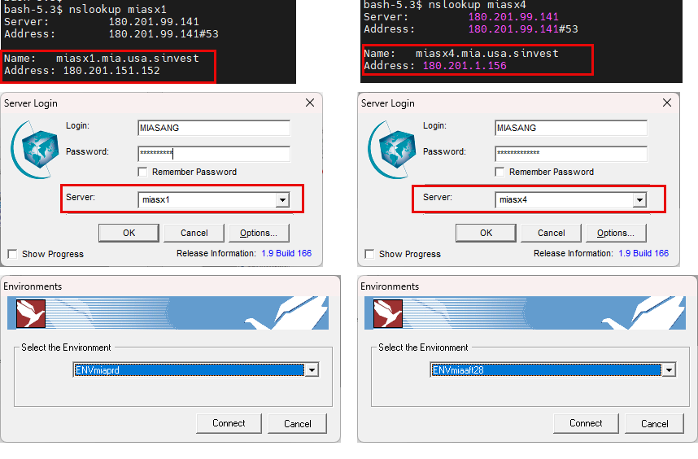
Source: BSI.IT.23.C4.03 / C4.08 (images 1-3 production; 5-7 non-production). Same login ID MIASANG in both (OBS-12 / OBS-13).
Exhibit A2: T24 production – ND.DEAL default list
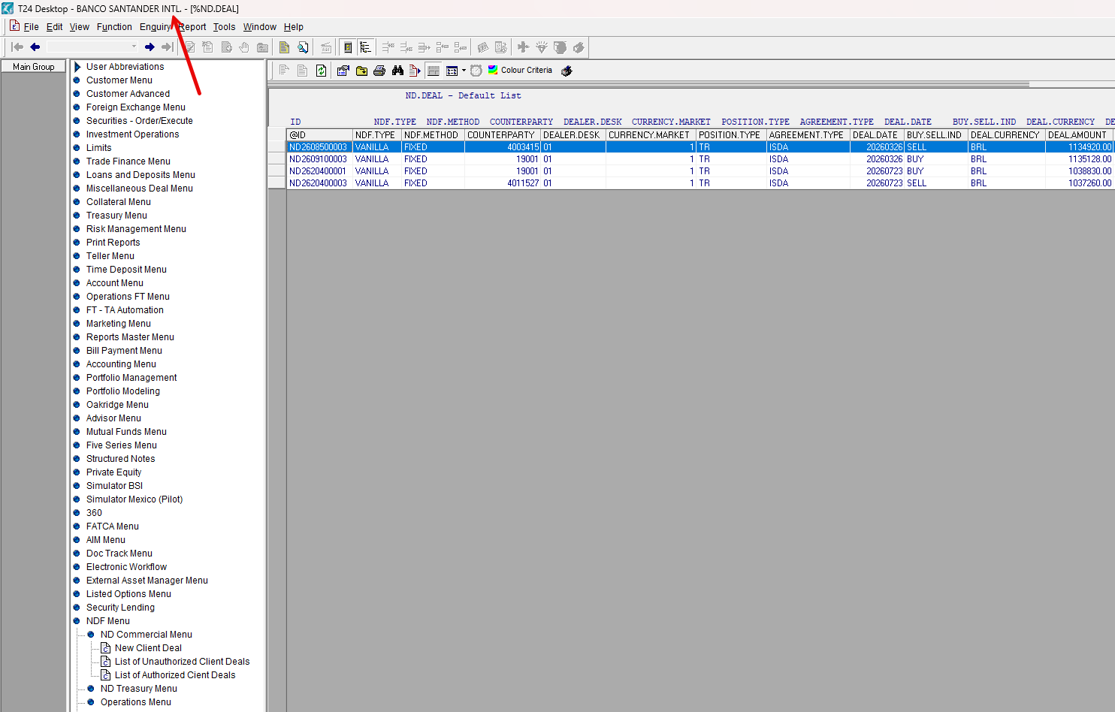
Source: BSI.IT.23.C4.03 / C4.08 (image 4). "T24 Desktop – BANCO SANTANDER INTL." – live NDF deals 03/2026 – 07/2026.
Exhibit A3: T24 non-production MIAAFT28 – ND.DEAL default list
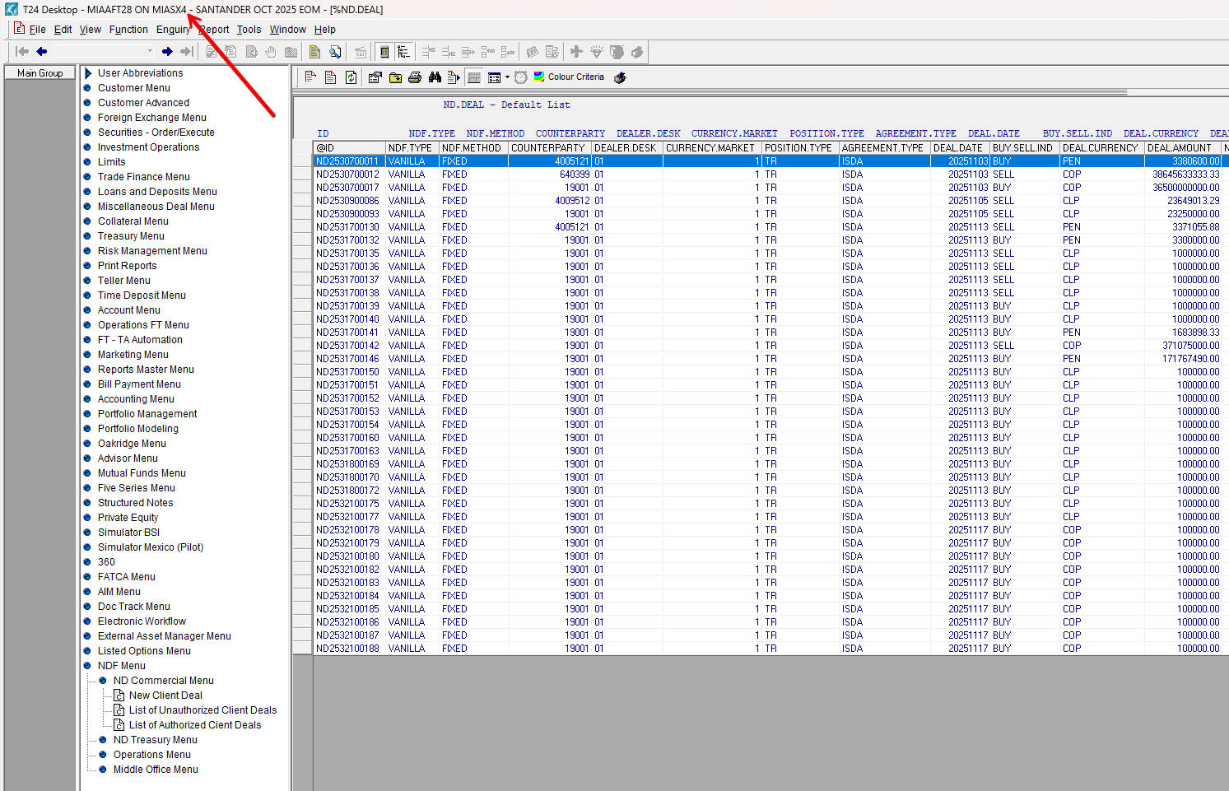
Source: BSI.IT.23.C4.03 / C4.08 (image 8). "MIAAFT28 ON MIASX4 – SANTANDER OCT 2025 EOM" – test deals dated 11/2025.
Referenced workbook: C4 WP 2026.xlsm – tab "Control Performance Assessment", rows 53 – 54 (Sample 1 Security Lending, Sample 2 NDF); tab "New Test Script".

